All of our templates are packed with:
- Extensions - These are modules/plugins/component to use on this template.
- Template - This is only the template install file
- Quickstart - This is your main quickstart package, it will help you to rebuild demo.
- Documentation
If this template is not downloaded directly from amazing-templates.com. Please, go to our website and download full template pakage.
This documentation file helps you build your site manualy

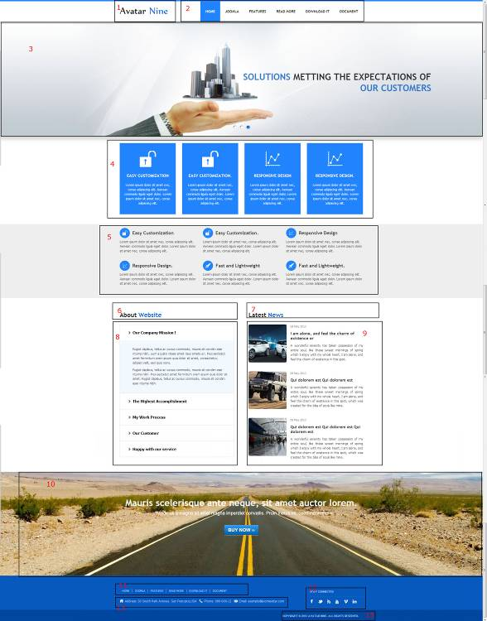
1.
Module Type: Custom HTML
Module Name: Logo (hide title)
Module Class Suffix: no-padding-marging avatar-template-logo
Position: Top-left
HTML source code:
<p><a href="Your Link Site "><span style="color: #000;">Your</span> Site Name</a></p>

2.
Module Type: Menu
Module Name: Main Menu
Module class suffix: _menu no-padding-marging
Menu class suffix: avatar-main-menu
Alternative layout: Responsive
Position: Top-right

3.
Module Type: Avatar Articles Nivo
Module Name: Banner Tool Home
Module Class Suffix: avatar-caption no-padding-marging avatar-banner-full
Module Postion: Tool (width of TOOL BLOCK is 100% (configuration in templates manager))

DATA
Go to Content Manager.
Creat New Category.
Create articles in category just created.
In a newly created articles, Select intro image and written content slide.
Then go to the Banner Tool Home Manager.
Select the category for slidershow.

4.
Module Type: Avatar Template Showcase
Module Name: Features Home News Style 5
Module class suffix: no-padding-margin-side
Module showcase: features_4
Position: content-top
Columns: 4
DATA
Go to Content Manager.
Creat "Features News Style 1" Category.
Create articles in category just created.
In a newly created articles, and add image icon like demo.
Then go to the Features Home News Style 5 Manager.
Select the category for display.

5.
Module Type: Avatar Template Showcase
Module Name: Features-2 Home News Style 5
Module class suffix: no-padding-margin-side
Module showcase: features_5
Position: full-2
columns: 3

DATA
Go to Content Manager.
Creat "Features NEws Style 1" Category.
Create articles in category just created.
In a newly created articles, and add image icon like demo.
Then go to the Features-2 Home News Style 5 Manager.
Select the category for display.

6.
Module Type: Custom HTML
Module Name: About Website title - Home new style 5
Module class suffix: no-padding-marging
Position: promo-bottom-left
HTML source code:
<h1 style="font-family: mainfont;">Latest <span class="avatar_text_color">News</span></h1>

7.
Module Type: Custom HTML
Module Name: Lastest News title - Home New Style 5
Module class suffix: no-padding-marging
Position: promo-bottom-right
HTML source code:
<h1 style="font-family: mainfont;">About <span class="avatar_text_color">Website</span></h1>

8.
Module Type: Custom HTML
Module Name: About Website - Home new style 5
Module class suffix: no-padding-margin-side
Position: promo-bottom-left
HTML source code:
<div id="accordion3" class="accordion avatar-accordion-2">
<div class="accordion-group">
<div class="accordion-heading"><a class="accordion-toggle" href="#collapseOne" data-toggle="collapse" data-parent="#accordion3">Our Company Mission !</a></div>
<div id="collapseOne" class="accordion-body in collapse" style="height: auto;">
<div class="accordion-inner">
<p>Fugiat dapibus, tellus ac cursus commodo, mauris sit condim eser ntumsi nibh, uum a justo vitaes amet risus amets un. Posi sectetut amet fermntum orem ipsum quia dolor sit amet, consectetur, adipisci velit, sed quia nons.</p>
<p>Fugiat dapibus, tellus ac cursus commodo, mauris sit condim eser ntumsi nibh. Posi sectetut amet fermntum orem ipsum quia dolor sit amet. Fugiat dapibus, tellus ac cursus commodo, mauris sit condim eser ntumsi nibh.</p>
</div>
</div>
</div>
<div class="accordion-group">
<div class="accordion-heading"><a class="accordion-toggle" href="#collapseTwo" data-toggle="collapse" data-parent="#accordion3">The Highest Accomplishment</a></div>
<div id="collapseTwo" class="accordion-body collapse" style="height: 0;">
<div class="accordion-inner">
<p>Fugiat dapibus, tellus ac cursus commodo, mauris sit condim eser ntumsi nibh, uum a justo vitaes amet risus amets un. Posi sectetut amet fermntum orem ipsum quia dolor sit amet, consectetur, adipisci velit, sed quia nons.</p>
<p>Fugiat dapibus, tellus ac cursus commodo, mauris sit condim eser ntumsi nibh. Posi sectetut amet fermntum orem ipsum quia dolor sit amet. Fugiat dapibus, tellus ac cursus commodo, mauris sit condim eser ntumsi nibh.</p>
</div>
</div>
</div>
<div class="accordion-group">
<div class="accordion-heading"><a class="accordion-toggle" href="#collapseThree" data-toggle="collapse" data-parent="#accordion3">My Work Process</a></div>
<div id="collapseThree" class="accordion-body collapse" style="height: 0;">
<div class="accordion-inner">
<p>Fugiat dapibus, tellus ac cursus commodo, mauris sit condim eser ntumsi nibh, uum a justo vitaes amet risus amets un. Posi sectetut amet fermntum orem ipsum quia dolor sit amet, consectetur, adipisci velit, sed quia nons.</p>
<p>Fugiat dapibus, tellus ac cursus commodo, mauris sit condim eser ntumsi nibh. Posi sectetut amet fermntum orem ipsum quia dolor sit amet. Fugiat dapibus, tellus ac cursus commodo, mauris sit condim eser ntumsi nibh.</p>
</div>
</div>
</div>
<div class="accordion-group">
<div class="accordion-heading"><a class="accordion-toggle" href="#collapseFour" data-toggle="collapse" data-parent="#accordion3">Our Customer</a></div>
<div id="collapseFour" class="accordion-body collapse" style="height: 0;">
<div class="accordion-inner">
<p>Fugiat dapibus, tellus ac cursus commodo, mauris sit condim eser ntumsi nibh, uum a justo vitaes amet risus amets un. Posi sectetut amet fermntum orem ipsum quia dolor sit amet, consectetur, adipisci velit, sed quia nons.</p>
<p>Fugiat dapibus, tellus ac cursus commodo, mauris sit condim eser ntumsi nibh. Posi sectetut amet fermntum orem ipsum quia dolor sit amet. Fugiat dapibus, tellus ac cursus commodo, mauris sit condim eser ntumsi nibh.</p>
</div>
</div>
</div>
<div class="accordion-group">
<div class="accordion-heading"><a class="accordion-toggle" href="#collapseFive" data-toggle="collapse" data-parent="#accordion3">Happy with our service</a></div>
<div id="collapseFive" class="accordion-body collapse" style="height: 0;">
<div class="accordion-inner">
<p>Fugiat dapibus, tellus ac cursus commodo, mauris sit condim eser ntumsi nibh, uum a justo vitaes amet risus amets un. Posi sectetut amet fermntum orem ipsum quia dolor sit amet, consectetur, adipisci velit, sed quia nons.</p>
<p>Fugiat dapibus, tellus ac cursus commodo, mauris sit condim eser ntumsi nibh. Posi sectetut amet fermntum orem ipsum quia dolor sit amet. Fugiat dapibus, tellus ac cursus commodo, mauris sit condim eser ntumsi nibh.</p>
</div>
</div>
</div>
</div>

9.
Module Type: Avatar Template Showcase
Module Name: Lastest News - Home New Style 5
Module class suffix: no-padding-margin-side
Module showcase: news
Position: promo-bottom-right
Columns : 1

DATA
Go to Content Manager.
Creat "Extension" Category.
Create articles in category just created.
In a newly created articles, and add image icon like demo.
Then go to the Lastest News - Home New Style 5 Manager.
Select the category for display.

10.
Module Type: Custom HTML
Module Name: slogan
Module class suffix: avatar-bg-road-1 no-padding-marging
Position: full-5
HTML source code:
<h1 style="text-align: center;">Mauris scelerisque ante neque, sit amet auctor lorem.</h1>
<p style="text-align: center; font-size: 18px;">Vivamus a magna sit amet magna imperdiet convallis. Proin metus mi, condimentum</p>
<p style="text-align: center; font-size: 18px;">&nbsp;</p>
<p style="text-align: center;"><a class="btn" href="#" target="_blank"><span style="font-size: 18px; line-height: 24px; font-weight: bold;">BUY NOW ››</span></a></p>

11.
Module Type: Menu
Module Name: Footer Menu
Module class suffix: no-padding-margin-side
Menu class suffix: avatar-footer-nav
Alternative layout: Responsive
Position: Footer-Left

12.
Module Type: Custom HTML
Module Name: Address
Module Class Suffix: avatar-module-border-top avatar-footer-address no-padding-marging
Position: Footer -left

HTML source code:
<ul style="display: table;">
<li class="avatar-address"><span style="line-height: 1.3em;">Address: Your Address</span></li>
<li class="avatar-phone"><span style="line-height: 1.3em;">Phone: Your Phone Number</span></li>
<li class="avatar-email"><span style="line-height: 1.3em;">Email: Your email</span></li>
</ul>

13.
Module Type: Custom HTML
Module Name: STAY CONNECTED
Module Class Suffix: no-padding-margin-side social-heading
Position: Footer -right
HTML source code:
<div class="avatar-footer-social avatar-module-border-top">
<a class="facebook" href="Your Facebook Link"> </a>
<a class="twitter" href="Your Twitter Link"> </a>
<a class="feed" href="Your Feed Link"> </a>
<a class="youtube" href="Your Youtube Link"> </a>
<a class="vimeo" href="Your Vimeo Link"> </a>
<a class="linkedin" href="Your Linkedin Link"> </a>
</div>

14.
Module Type: Custom HTML
Module Name: copyright
Module Class Suffix: avatar-copyright
Position: Footer

HTML source code:
<p><a href="www.joomavatar.com">Copyright © 2013 Avatar Nine. All Rights Reserved.</a></p>

